EXPERIMENT-12

CREATE AND EXECUTE STORE PROCEDURE AND FUNCTION
create database library;
use library;
create table book6(bid integer,availability integer, author varchar(30),title varchar(40),price integer,primary key(bid));
desc book6;
insert into book6 values (1111,25,'ruskin band','the blue umbrella',250);
insert into book6 values(2222,50,'mahatma gandhi','the experiments of truth',300);
insert into book6 values(3333,65,'valmiki','ramayana',400);
insert into book6 values(4444,70,'vedha vyasa','mahabharatha',400);
insert into book6 values(5555,85,'william shakesphire','romeo and juliet',500);
select * from book6;
1.PROCEDURE
delimiter //
create procedure display3()
begin
select*from book6;
end;
call display3()
OUTPUT:
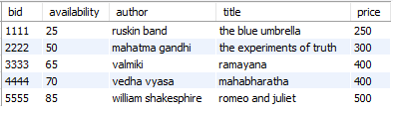
2.FUNCTION
delimiter //
create function multiplication(num1 int,num2 int)
returns int deterministic
begin
declare result int;
set result=num1*num2;
return result;
end;
select multiplication(8,9);
OUTPUT:
